Using JBuilder with BEA WebLogic servers
This chapter explains how to use to set up and use BEA WebLogic servers with JBuilder. JBuilder supports WebLogic Server 6.x, WebLogic Server 7.x, and WebLogic Platform 8.1.

Service packs
JBuilder requires WebLogic 6.1 with Service Pack 5 for proper operation. For WebLogic 7.0, Service Pack 4 is required. For WebLogic 8.1, you will need Service Pack 1.

Configuring JBuilder for WebLogic servers
To configure JBuilder settings to target WebLogic servers,
- Choose Tools|Configure Servers.
The Configure Servers dialog box appears.
- Select the WebLogic server you want to configure by clicking it in the pane on the left.
The right side of the dialog box lists the default settings for the selected server. The General page has fields that all WebLogic servers have in common, while the Custom page has fields that are specific to the selected server. In some cases, modifying a Custom setting will update a setting on the General page.
- Check the Enable Server check box at the top of the dialog box.
Checking this option enables the fields for the selected application server. You won't be able to edit any fields until it is checked. The Enable Server check box also determines whether this server will appear in the list of servers when you select a server for your project using the Servers page of the Project|Project Properties dialog box.
JBuilder provides default settings for the selected server. If JBuilder's default settings are not appropriate, edit any of the settings as needed. Some servers require you to enter settings in addition to the defaults. Clicking the OK button in this dialog box when not all required values are set or selecting another server while the current one is enabled displays a message dialog box that informs you about the missing settings.
- If you want to change any of the settings, click the ellipsis (…) button next to the field and make your changes. Assuming you installed WebLogic Platform 8.1 into a BEA_HOME directory with the name bea, your home directory should be [drive]:/bea/weblogic81/server. For WebLogic Server 7.x, you home directory should be [drive]:/bea/weblogic71/server. For WebLogic 6.x, your home directory should be [drive]:/bea/wlserver6.0 or [drive]:/bea/wlserver6.1.
For WebLogic Platform 8.1 and WebLogic Server 7.x, the working directory is set when you set the domain directory using the Custom page. For now, you can leave it unchanged. For WebLogic 6.x, the home directory is the default working directory. It is not necessary to change this.
- Click the Custom tab to view fields unique to the server. Change or fill in these fields:
  - BEA Home Directory: The BEA Home Directory is the directory into which you installed the WebLogic Server and that contains the file registry.xml. JBuilder assigns a default value for the BEA Home Directory that varies depending on the version of the WebLogic Server installed.
  - JDK Installation Directory: For WebLogic Platform 8.1, the directory is <bea home>/jdk141_03. For WebLogic 7.x, the directory is <bea home>/jdk131_08. For WebLogic 6.x, the directory is <bea home>/jdk131_06.
  - Domain Directory: For WebLogic Platform 8.1 and WebLogic Server 7.x only. Use the ellipsis (…) button to select a directory as your domain directory. The domain directory is the directory where your WebLogic domain is stored. For WebLogic 7.x, this is user_projects/mydomain. For WebLogic 8.1, it is user_projects/domains/mydomain. Setting the domain directory sets the working directory value on the General page. For more information about WebLogic domains, see your WebLogic documentation.
  - Domain Name: For WebLogic 6.x only. The WebLogic domain name. JBuilder sets the domain name by default to "mydomain." For more information about WebLogic domains, see your WebLogic documentation.
  - User Name: The user name you use to authenticate yourself to the server. This field appears for WebLogic Platform 8.1 and WebLogic Server 7.x.
  - Password: The password you use to authenticate yourself to the server.
  - Server Name: The name you specify is used as a VM parameter for starting the server. JBuilder suggests a default name of "myserver."
  - Listen Address: Specifies a listen address for this server. The host value must be either the DNS name or the IP address of the server. If you do not specify a Listen Address, the server uses either the machine's DNS name or its IP address.
  - Listen Port: Specifies the non-SSL listen port for this server. If you do not specify a Listen Port, the server uses 7001 as the default.
  - Version: Select the combination of WebLogic version and service pack you are configuring from the drop-down list.
The Custom page of the Tools|Configure Servers dialog box for WebLogic 7.x and 8.x now includes Listen Address and Listen Port fields. If you edit fields such as User Name, Server Name, Listen Address, and so on, the corresponding entries in the Server Deployment dialog box and the node deployment dialog box are updated accordingly.
  - Add An Admin Console Item To The Tools Menu: Checking this check box adds the WebLogic Admin Console item to JBuilder's Tools menu. You must also fill in the next field, Web Browser Path, to have the menu item added.
  - Web Browser Path: Specify the path and file name of the web browser of your choice. For example, you might specify c:/program files/Internet Explorer/iexplore.exe if you want to use Microsoft's Internet Explorer.
  - Add A Configuration Wizard Item To The Tools Menu: For WebLogic Platform 8.1 and WebLogic Server 7.x only. Adds a WebLogic Configuration Wizard item to the JBuilder Tools menu. When you select this menu item, the BEA WebLogic Configuration wizard begins, which guides you through the steps of configuring the domain for your use.
  - Use External Compiler: Check this check box if you want to use an external compiler to generate stub files instead of JBuilder's compiler, bcj. WebLogic Platform 8.1 uses the appc compiler, while earlier versions use the ejbc compiler.
  - Path: Specify the fully-qualified name of the compiler you want to use. You can use the ellipsis (…) button to navigate to the compiler location.
- Choose OK to close the dialog box.

Creating a duplicate configuration to edit
Once you've created a server configuration, you might find you'd like to have a similar one, but with some slight differences. Follow these steps to create a duplicate configuration you can then edit:
- Choose Tools|Configure Servers to display the Configure Servers dialog box.
- Select the server configuration you would like to duplicate from the left pane.
- Click the Copy button at the bottom of the left pane to display the Copy Server wizard:
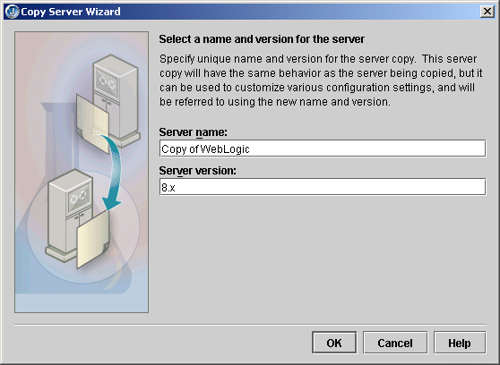
- Specify the name you want to use to identify this server configuration in the Name For This Server field.
- Specify the server version in the Version For This Server field.
- Click OK.
- Select your new configuration in the left pane of the Configure Servers dialog box and make the changes to the settings you need using the General and Custom pages.
Copying a server configuration also creates copies of that server's tools. You could, therefore, create a duplicate server configuration and modify just the server's tools as the only difference between the two configurations.

Created libraries
When you configure JBuilder to target a WebLogic server, required libraries are created for you that contain all the application server files you will need for enterprise bean development. These are the libraries created for you, listed by WebLogic server version:
WebLogic Platform 8.1
WebLogic 8.1 Client: All JARs needed to run a client.
WebLogic 8.1 Deploy: JARs needed to run the WebLogic 8.1 deploy tool.
WebLogic Server 7.x
WebLogic 7.x Client: All JARs needed to run a client.
WebLogic 7.x Deploy: JARs needed to run the WebLogic 7.x deploy tool.
WebLogic Server 6.x
WebLogic 6.x Client: All JARs needed to run a client.
WebLogic 6.x Deploy: JARs needed to run the WebLogic 6.x deploy tool.

Adding a service pack
If you want to add a service pack to your application server configuration, follow these steps:
- Choose Tools|Configure Servers.
- Select your server from the list of servers in the pane on the left side of the dialog box.
- Click the General tab, then the Class tab, if they are not already selected.
- Click Add.
- Navigate to the location of the service pack JAR file.
- Click OK twice to close all dialog boxes.

Selecting a server
If you are working with more than one version of WebLogic Server and have configured JBuilder for all versions, you must select which version you want to use for your current project. Choose Project|Project Properties and select Server in the tree to display the Server page.
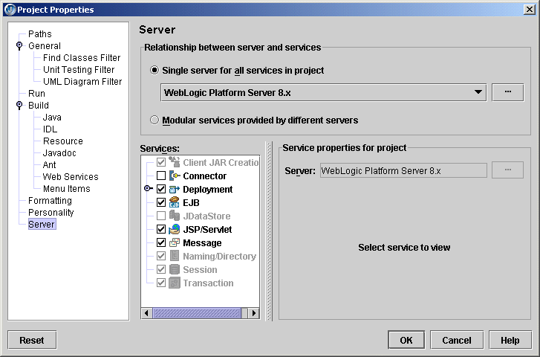
You can click the Help button on this page for assistance using this page to select a server.
JBuilder can target multiple servers. You can choose a single application server for all stages of EJB and web application development, or you can choose different servers for different aspects of development. For example, you can select one server to use to develop enterprise beans and another to develop web applications.
Decide whether you want to use a single server for all aspects of development or different servers to handle different areas of development.
- To use a single server,
  - Select the Single Server For All Services In Project option and select the server from the drop-down list.
  - If you want to make changes to the configuration settings for the server, click the ellipsis (…) button and edit the settings you want on the General and Custom pages. Click OK.
You can also use this dialog box to select a different server.
- To use different servers for different services,
  - Select the Modular Services Provided By Different Servers option.
  - Check the check boxes next to all the services for which you want to specify an application server in the Services list.
  - Click one of the checked services to select it in the Services list.
Note that the web module won't be deployed automatically if it is part of an EAR.
  - In the Service Properties For Project group box, use the Server drop-down list to select the server you want to use for this service.
If server-specific properties are available for the server you selected for the particular service you are working with, they will appear below the Server drop-down list. If the Deployment service is selected, a Build Target For Deploying To Server drop-down list appears on the Service Properties For Project panel. Select the type of build you want to occur. If the EJB service is selected, you'll see read-only information appear that is intended to help you decide which server is appropriate for your needs.
If you select the JSP/Servlet service, the service properties include a Map Project Apps At Runtime option. When this option is selected (the default value) all web applications in the project deploy from the web application directory and not as a WAR when the server starts up.
For WebLogic 7.x - 8.1: If you select the EJB service, the service properties include a combo box with options to deploy (auto-deploy) data sources for all EJB modules in the project. These are the options:
    - Map Project Data Sources: Maps data sources for all EJB modules in config.xml for the domain specified in the server configuration. Datasource entries are removed when the server shuts down.
    - Map And Persist Project Data Sources: Maps data sources for all EJB modules in config.xml for the domain specified in the server configuration. Data Source information is persisted in config.xml. Datasource entries are removed when the server shuts down.
    - Do Not Map Project Data Sources: Does not map any data sources.
  - If you want to make changes to the configuration settings for the server selected for the service, click the ellipsis (…) button and edit the settings you want on the General and Custom pages. Click OK.
  - Repeat these steps for each service you want access to.
Click OK when you are finished with the dialog box to select your specified server for your current project.
If you neglect to select one ore more servers for a project, the Server page of the Project Properties dialog box appears when you start an EJB wizard from the object gallery. All EJB projects must have one or more selected servers.

Working in JBuilder
JBuilder supports WebLogic servers in all areas of development. This section describes some of the WebLogic-specific features available to you.

Using existing code
If you already have existing WebLogic EJB 2.0 deployment descriptors for enterprise beans you created previously, you can create a new EJB module that contains the descriptors. You have two options:
- Use the EJB Module From Descriptors wizard, which creates a new EJB module that contains the deployment descriptors.
- Use the Project For Existing Code wizard, which creates a new JBuilder project containing one or more new EJB modules that contain the deployment descriptors.
See "Creating an EJB module from existing deployment descriptors" for complete information.

Creating WebLogic entity beans in JBuilder
JBuilder's EJB Designer has support for WebLogic-specific features. The entity bean inspector includes options such as optimistic concurrency and field groups. There is a WebLogic version of the Table Map Editor. When creating relationships between entity beans, there are WebLogic versions of the relationship inspector and a special WebLogic RDBMS Relation Editor. For information about using these tools, see "Adding WebLogic table references" and "Specifying a WebLogic 6.x - 8.x relationship".

Using the DD Editor
The DD Editor has several WebLogic-specific pages for information that applies only to WebLogic servers. For information about using the DD Editor to edit J2EE modules, see "Editing J2EE deployment descriptors." Whenever a WebLogic-specific page is displayed in the DD Editor, you can press F1 for help on that particular page. You'll also find it convenient to have a copy of your server's documentation handy to look up the type of information your server requires in the deployment descriptors.

Compiling
To set APPC or EJBC options for compiling your WebLogic beans, right-click the EJB module node in the project pane, choose Properties and select the Build|WebLogic page. This page contains the options for your WebLogic compiler. Here, for example, are the APPC options for WebLogic Platform 8.1:
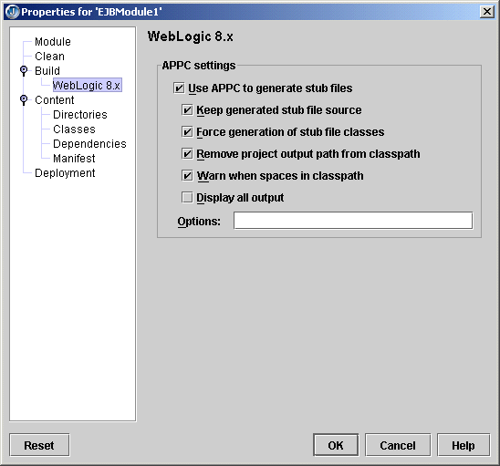

Starting the server
To prepare to start the server from within JBuilder, create a server runtime configuration. Follow these steps:
- Choose Run|Configurations.
- In the dialog box that appears, click the New button.
- Select Server from the Type drop-down list.
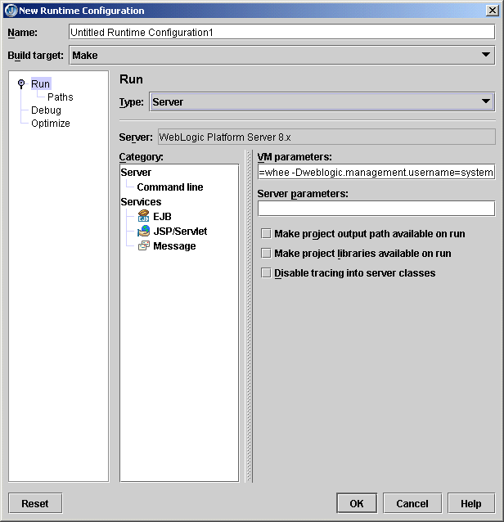
- In the Name field, enter a name, such as Server or something that will identify the run configuration.
- Fill in the VM Parameters and Server Parameters needed to run the server. If you've selected a target application server as described in "Selecting a server," default values are already in place.
- Click OK.
To start the server, click the down-arrow next to the Run Project icon () and select the server run configuration you just created.

Remote deploying
To deploy a deployable module to a remote server, follow these instructions for your version of WebLogic Server:

WebLogic Application Sever 7.x and WebLogic Platform Server 8.1
Choose one of these options:
- Using the Tools|Server Deployment command:
  - Choose Tools|Server Deployment to display the WebLogic Deploy Settings dialog box.
  - From the Action drop-down list, select Deploy.
  - Select the archive to deploy from the drop-down Archive To Deploy list or browse to the archive you want to deploy using the ellipsis (…) button.
  - Set the Admin URL to the remote server, such as <HOST NAME>:<port number>.
  - Enter the User Name and Password that matches the remote server configuration.
  - Choose OK.
- Deploying from the project pane:
  - Right-click the module you want to deploy in the project pane and choose Properties.
  - Select Deployment in the tree to display the Deployment page.
  - Set the Admin URL to Set the Admin URL to the remote server, such as <HOST NAME>:<port number>.
  - Right-click the module you want to deploy in the project pane and choose Deploy Options|Deploy.

WebLogic Server 6.x
Choose one of these options:
- Using the Tools|Server Deployment command:
  - Choose Tools|Server Deployment to display the WebLogic Deploy Settings dialog box.
  - Select the Deploy action.
  - In the Options field, specify -host<host name> -port<port number>.
  - Set the password to match that required by the remote server configuration.
  - Choose OK.
- Deploying from the project pane:
  - Right-click the module you want to deploy in the project pane and choose Properties.
  - Select Deployment in the tree to display the Deployment page.
  - Set the Admin URL to Set the Admin URL to the remote server, such as <HOST NAME>:<port number>.
  - Right-click the module you want to deploy in the project pane and choose Deploy Options|Deploy.

WebLogic 8.x Platform Server deployment
The OpenTool for WebLogic 8.x Platform Server has improved deployment features. You can now deploy submodules so you can deploy a module that has been newly added to an EAR or redeploy it.
Use the deploy options on the context menu when you right-click the archive and choose Properties. You can also access the deployment options when you choose Tools|Server Deployment and choose from the actions on the drop-down Action list.
There are two additional options on the context menu that appears when you right-click the archive and choose Deploy Options: Deactivate and Activate. Deactivate suspends deployed components, leaving staged data in place for subsequent reactivation. To reactivate a deactivated component, choose Activate. To totally remove the application and any staged data from the server, choose Undeploy.

Remote debugging
To prepare to debug remotely, launch the WebLogic Server with debug parameters. To do this, modify startWebLogic.sh in your domain directory and add the follow parameters to the JAVA_OPTIONS variable:

-Djava.compiler=NONE
-Xrunjdwp:transport=dt_socket,server=y,address=3999,suspend=n
Within JBuilder, follow these steps:
- In the project from which you want to launch the remote debug session, click Run|Configurations. If you have not yet created a server type run configuration, click New and select type Server. If you have already created a server type run configuration, select it and choose Edit.
- Select Debug|Remote in the tree.
- Check the Enable Remote Debugging option.
- Enter the host name (the name of the machine on which the server is running.)
- Click OK.
- Click the down arrow next to the Debug Project icon () on the JBuilder toolbar and select the debug run configuration you just created or edited. You will now be able to set breakpoints in Java code, such as in EJBs, servlets, and so on.

Remote debugging of JavaServer Pages
To debug JSPs remotely, open the project containing the web application you want to debug and follow these steps,
- Expand the web application node in the project and expand the deployment descriptors node under the web application node.
- Double-click weblogic.xml and add the following descriptor elements:

- <jsp-descriptor>
- <jsp-param>
- <param-name>keepgenerated</param-name>
- <param-value>true</param-value>
- </jsp-param>
- <jsp-param>
- <param-name>debug</param-name>
- <param-value>true</param-value>
- </jsp-param>
- <jsp-param>
- <param-name>precompile</param-name>
- <param-value>true</param-value>
- </jsp-param>
- <jsp-param>
- <param-name>compileFlags</param-name>
- <param-value>-g</param-value>
- </jsp-param>
- </jsp-descriptor>
- Rebuild project and deploy the web application (as a WAR).
- Launch the Weblogic server with debug parameters. To do this, modify startWebLogic.sh in your domain directory and add the following parameters to the JAVA_OPTIONS variable:

- -Xdebug -Xnoagent -Djava.compiler=NONE
- -Xrunjdwp:transport=dt_socket,server=y,address=3999,suspend=n
Note that these steps can be done on a local machine provided Weblogic is set up and configured in JBuilder.
On the local machine, follow these steps:
- Transfer the project to the local machine where you wish to debug the JSP and open the project in JBuilder.
- Under the source path for the project (normally <PROJECT_ROOT>/src), create a directory named jsp_servlet. If you need to use a source path other than the default, you can obtain this setting from the General page of the Project Properties dialog box.
- Copy the JSP(s) you want to debug to the directory you just specified.
- Open the JSP(s) and set breakpoints where required.
- Choose Run|Configurations.
- Click the New button, select the Application from the drop-down list, and click the Debug tab.
- Check the Enable Remote Debugging option.
- Enter the host name of the remote server in the Host Name field and set the Build Target to None. Accept all other default settings.
- Attach to the remote server by clicking on the debug project icon in the toolbar.
- Load your JSP in a web browser. The debugger stops at breakpoints in the JSP.

Updating projects with the latest server settings
Every time you open a project, JBuilder updates it with the latest server settings for the project's selected server(s). So, for example, if you have modified server settings for one project and you have others that use the same server configuration, the next time you open those other projects, your modified server settings will be in force automatically. If you want to use a similar but unique server configuration for a particular project, create a duplicate configuration using the Copy button, and use the Copy Servers wizard to edit it to your needs.
Be aware that this automatic updating of projects with the latest server settings can occur only with server configurations modified in JBuilder 9. If you attempt to transfer server libraries from a previous JBuilder version, your projects won't be updated with them. You can still tell JBuilder to update the project manually:
- Right-click the project node of the project you want to update in the project pane and choose Properties.
- Select the Servers page.
- Click the ellipsis (…) button next to your selected single server or the separate service servers and make your changes.
- Click OK to close the dialog box.

